Supplementary Appendix
Supplementary appendix to accompany “QDOT MICRO™ versus THERMOCOOL® SMARTTOUCH™ and THERMOCOOL SMARTTOUCH® Surround Flow in radiofrequency ablation of paroxysmal atrial fibrillation”.
Appendix 1 | Statistical Analyses Details
Appendix 2 | Ranking of prognostic factors and availability in Q-FFICIENCY, SMART-AF, and SMART-SF cohorts
Appendix 3 | Flow chart of QDOT patients who received QMODE+ and QMODE
Appendix 4 | Patient characteristic for procedure time
Appendix 5 | Patient characteristic for fluoroscopy time
Appendix 6 | Patient characteristic tables clinical success at 12 months and rhythm monitoring-adjusted recurrence
Appendix 7 | Forest plot of IPTW results for each procedure time scenario
Appendix 8 | Forest plot of IPTW results for each fluoroscopy time scenario
Appendix 9 | Kaplan-Meier curve of clinical success at 12 months (adjusted for all factors)
Appendix 10 | Forest plot of IPTW results for each clinical success at 12 months scenario
Appendix 11 | Forest plot of IPTW results for rhythm monitoring-adjusted recurrence scenario

Appendix 1: Statistical Analyses Details
Study Population
For the Q-FFICIENCY trial, individual patient data from the per-protocol population was used for all outcomes analyzed (N=166). All subjects enrolled met the eligibility criteria and underwent RF ablation. They were treated with the QDOT catheters and had been treated for the study-related arrhythmia without major protocol deviations.
For the SMART-AF trial, individual patient data from the primary effectiveness population was used for all the outcomes analyzed (N=114). All subjects enrolled met the eligibility criteria and underwent insertion of the ST catheter and AF ablation procedure.
For the SMART-SF trial, individual patient data from the modified intention-to-treat (mITT) population (N=155) was used for procedure and fluoroscopy time analyses. The effectiveness population (N=78) was used to analyze clinical success at 12 months and rhythm monitoring-adjusted recurrence. The mITT population included subjects enrolled who met the eligibility criteria and had the STSF catheter inserted. The effectiveness population included subjects who were eligible to participate in the effectiveness phase of the study for effectiveness evaluation at 6-to-9 and 12-month visits.
Identification and Rank Ordering of Factors for Population Adjustment
Differences in baseline characteristics between trials can lead to biased comparative effectiveness estimates if left unadjusted, due to confounding by difference in prognostic factors and treatment-effect modifiers.²⁷ In this study, first, a list of potential prognostic factors and treatment-effect modifiers were identified a priori based on a literature review and the Q-FFICIENCY, SMART-AF, and SMART-SF trials’ individual patient data. Next, univariate regressions were conducted to evaluate the prognostic strength of each factor considered for adjustment for both procedure time and clinical success outcomes. Differences of each factor between trials was assessed by calculating the standardized mean difference (SMD) where an SMD of 0–0.1, >0.1 to ≤0.2, and >0.2 indicated small difference, moderate difference, and substantial difference, respectively.²⁸ The factors were then ordered from largest to smallest in the order of importance, considering both prognostic strength and cross-trial differences of each factor. The same ranking obtained for the procedure time analysis was used for the fluoroscopy time analysis. The same ranking obtained for the clinical success analysis was used for the atrial arrhythmia monitoring-adjusted recurrence analysis (Appendix 2).
Inverse Probability of Treatment Weighting
The weights were derived from propensity scores²⁹ which were calculated using a logistic regression model that predicted assignment to Q-FFICIENCY trial as a function of the selected baseline characteristics. Average treatment effect in the treated weighting was used, wherein patients from Q-FFICIENCY were kept as observed (i.e., received a weight of one), and patients in the pooled SMART-AF and SMART-SF cohort received a weight of p/(1 − p), where p is the propensity score predicting inclusion in the Q-FFICIENCY trial.¹⁰
Estimating Comparative Efficiency and Effectiveness
The comparative effectiveness of QDOT to pooled ST/STSF was determined in terms of procedure time, fluoroscopy time, clinical success at 12 months, and rhythm monitoring-adjusted recurrence. Comparative effectiveness was estimated using both the unadjusted (or naïve) comparison (i.e., QDOT versus pooled ST/STSF prior to IPTW), and the adjusted comparison (i.e., with IPTW).
For procedure time and fluoroscopy time (continuous outcomes), a generalized linear model with a log link (with weights applied for the adjusted comparison) was used to estimate a ratio of means (RoM) and 95% confidence interval (CI). The variance was estimated using a robust sandwich variance estimator.
For clinical success at 12 months (time-to-event outcome), a Cox proportional hazards model (with weights applied for the adjusted comparison) was used to estimate hazard ratio (HR) and 95% CI. The variance was estimated using a robust sandwich variance estimator. The proportional hazards assumption was assessed based on visual inspection of the log-cumulative hazard plot, visual inspection of the Schoenfeld residuals plot, and performance of the Grambsch-Therneau test (with a P-value <0.05 considered to indicate a violation of the assumption).³⁰
Differences in the intensity and frequency of rhythm monitoring may underestimate or overestimate the incidence of arrhythmia recurrence post-ablation, and such differences in trial methods are not typically adjusted for in IPTW. The comparison of rhythm monitoring strategies used in the Q-FFICIENCY, SMART-AF, and SMART-SF trials revealed differences in the monitoring frequency and methods. Rhythm monitoring was scheduled at 1-, 3-, 6-, and 12-month follow-up in the Q-FFICIENCY and SMART-AF trials. Patients in the SMART-AF trial were also monitored at 9-month follow-up. In contrast, scheduled monitoring in the SMART-SF trial occurred at 1- and 12-month follow-up, and once between 6- and 9-month follow-up. The Q-FFICIENCY and SMART-AF trials also included unscheduled monitoring, whereas the SMART-SF trial did not. All trials monitored rhythm using ECG, however, the Q-FFICIENCY trial included use of 24-hour Holter monitoring and TTM, the SMART-AF trial included use of TTM, and the SMART-SF trial included use of 1- to 7-day Holter monitoring.
To account for differences in monitoring encounters that may have led to missed observed atrial arrhythmia recurrence events, analyses were conducted to predict observed atrial arrhythmia recurrence events in the SMART-AF and SMART-SF studies through standardizing the number of monitoring encounters to those in the Q-FFICIENCY study. This approach assumed that increased monitoring in any given trial would result in increased additional events. A negative binomial regression model with an offset for the number of potential monitoring encounters (with weights applied for the adjusted comparison) was used to derive a rate ratio (RR) and 95% CI.
Appendix 2: Ranking of prognostic factors and availability in Q-FFICIENCY, SMART-AF, and SMART-SF cohorts
Prognostic Factor | Procedure Time and Fluoroscopy Time Ranking | Clinical Success at 12 months and Atrial Arrhythmia Recurrence Ranking
Race | 1 | 1
Age | 2 | 4
Thromboembolic event | 3 | 6
Other arrhythmia | 4 | 10
Hypertension | 5 | 2
Ethnicity | 6 | 12
LA diameter | 7 | 9
Diabetes | 8 | 3
Sex | 9 | 11
Heart disease | 10 | 13
LVEF | 11 | 5
Ablation procedure in last year | 12 | 8
Duration of AF | 13 | 7
Abbreviations: AF = atrial fibrillation; LA = left atrial; LVEF = left ventricular ejection fraction
Appendix 3: Flow chart of QDOT patients who received QMODE+ and QMODE
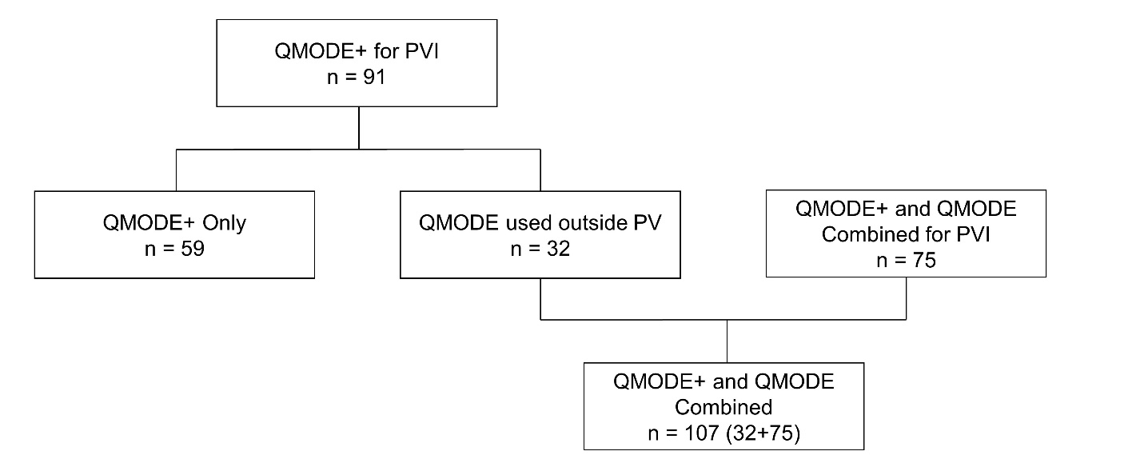
Abbreviations: PV = pulmonary vein; PVI = pulmonary vein isolation

Appendix 4: Patient characteristic for procedure time
 |  | Q-FFICIENCY | SMART-AF + SMART-SF |  | SMART-AF |  | SMART-SF
Characteristic |  | Per-protocol population | Pooled | SMD | Primary effectiveness | SMD | mITT population | SMD
N |  | 166 | 269 |  | 114 |  | 155
Sex (female), n (%) |  | 65 (39.2) | 93 (34.6) | 0.095 | 31 (27.2) | 0.256 | 62 (40.0) | 0.017
Race (non-white), n (%) |  | 18 (10.8) | 10 (3.7) | 0.277 | 6 (5.3) | 0.206 | 4 (2.6) | 0.335
Ethnicity (Hispanic/Latino), n (%) |  | 6 (3.6) | 4 (1.5) | 0.135 | 3 (2.6) | 0.057 | 1 (0.6) | 0.207
Diabetes, n (%) |  | 33 (19.9) | 35 (13.0) | 0.186 | 13 (11.4) | 0.235 | 22 (14.2) | 0.152
Hypertension, n (%) |  | 115 (69.3) | 158 (58.7) | 0.221 | 68 (59.6) | 0.202 | 90 (58.1) | 0.235
Heart disease -compositeª, n (%) |  | 15 (9.0) | 20 (7.4) | 0.058 | 10 (8.8) | 0.009 | 10 (6.5) | 0.097
Thromboembolic event - composite^{b}, n (%) |  | 18 (10.8) | 16 (5.9) | 0.177 | 6 (5.3) | 0.206 | 10 (6.5) | 0.157
Other arrhythmia - composite^{c}, n (%) |  | 44 (26.5) | 94 (34.9) | 0.184 | 42 (36.8) | 0.224 | 52 (33.5) | 0.154
Ablation procedure within 1 year prior to enrollment, n (%) |  | 3^{d} (1.8) | 10 (3.7) | 0.117 | 2 (1.8) | 0.004 | 8 (5.2) | 0.184
Age | mean (SD) | 63.16 (11.03) | 60.68 (10.72) | 0.228 | 57.99 (10.96) | 0.470 | 62.66 (10.13) | 0.047
Age | median [IQR] | 65.50 [56.25, 71.00] | 61.00 [53.00, 69.00] | 0.228 | 59.00 [51.25, 66.00] | 0.470 | 64.00 [55.00, 71.00] | 0.047
Age | median [range] | 65.50 [24.00, 83.00] | 61.00 [25.00, 83.00] | 0.228 | 59.00 [25.00, 77.00] | 0.470 | 64.00 [35.00, 83.00] | 0.047
Left ventricle ejection fraction, % | mean (SD) | 59.69 (7.00) | 60.05 (7.28) | 0.050 | 60.26 (7.96) | 0.076 | 59.89 (6.74) | 0.028
Left ventricle ejection fraction, % | median [IQR] | 60.00 [55.00, 65.00] | 60.00 [55.00, 65.00] | 0.050 | 60.00 [55.00, 65.00] | 0.076 | 60.00 [55.00, 65.00] | 0.028
Left ventricle ejection fraction, % | median [range] | 60.00 [40.00, 75.00] | 60.00 [40.00, 85.00] | 0.050 | 60.00 [40.00, 84.00] | 0.076 | 60.00 [40.00, 85.00] | 0.028
LA Diameter | mean (SD) | 38.19 (5.93) | 38.66 (5.76) | 0.081 | 38.39 (5.61) | 0.035 | 38.86 (5.87) | 0.114
LA Diameter | median [IQR] | 38.00 [34.00, 42.00] | 39.00 [35.00, 43.00] | 0.081 | 38.00 [34.75, 43.00] | 0.035 | 39.00 [35.00, 43.00] | 0.114
LA Diameter | median [range] | 38.00 [20.00, 50.00] | 39.00 [22.00, 50.00] | 0.081 | 38.00 [26.00, 50.00] | 0.035 | 39.00 [22.00, 50.00] | 0.114
Duration of symptomatic AF in months | mean (SD) | 51.94 (77.11) | 54.45 (65.02) | 0.035 | 65.91 (65.16) | 0.196 | 46.03 (63.82) | 0.084
Duration of symptomatic AF in months | median [IQR] | 18.00 [6.00, 60.00] | 30.00 [11.00, 72.00] | 0.035 | 48.00 [18.00, 89.00] | 0.196 | 24.00 [8.00, 60.00] | 0.084
Duration of symptomatic AF in months | median [range] | 18.00 [1.00, 432.00] | 30.00 [2.00, 480.00] | 0.035 | 48.00 [2.00, 306.00] | 0.196 | 24.00 [2.00, 480.00] | 0.084
Small Difference (SMD 0.0 to 0.1)
Moderate Difference (SMD >0.1 to 0.2)
Substantial Difference (SMD >0.2)
Abbreviations: AF = atrial fibrillation; IQR = interquartile range; LA = left atria; mITT = modified intention-to-treat; SD = standard deviation; SMD = standardized mean difference
Appendix 5: Patient characteristic tables fluoroscopy time
 |  | Q-FFICIENCY | SMART-AF + SMART-SF |  | SMART-AF |  | SMART-SF
Characteristic |  | Per-protocol population | Pooled | SMD | Primary effectiveness | SMD | mITT population | SMD
N |  | 136 | 263 |  | 114 |  | 149
Sex (female), n (%) |  | 53 (39.0) | 90 (34.2) | 0.099 | 31 (27.2) | 0.252 | 59 (39.6) | 0.013
Race (non-white), n (%) |  | 14 (10.3) | 10 (3.8) | 0.256 | 6 (5.3) | 0.189 | 4 (2.7) | 0.313
Ethnicity (Hispanic/Latino), n (%) |  | 3 (2.2) | 4 (1.5) | 0.051 | 3 (2.6) | 0.028 | 1 (0.7) | 0.129
Diabetes, n (%) |  | 26 (19.1) | 33 (12.5) | 0.181 | 13 (11.4) | 0.216 | 20 (13.4) | 0.155
Hypertension, n (%) |  | 93 (68.4) | 154 (58.6) | 0.205 | 68 (59.6) | 0.183 | 86 (57.7) | 0.222
Heart disease - compositeª, n (%) |  | 12 (8.8) | 19 (7.2) | 0.059 | 10 (8.8) | 0.002 | 9 (6.0) | 0.106
Thromboembolic event - composite^{b}, n (%) |  | 15 (11.0) | 16 (6.1) | 0.178 | 6 (5.3) | 0.212 | 10 (6.7) | 0.152
Other arrhythmia - composite^{c}, n (%) |  | 38 (27.9) | 92 (35.0) | 0.152 | 42 (36.8) | 0.191 | 50 (33.6) | 0.122
Ablation procedure within 1 year prior to enrollment, n (%) |  | 3 (2.2) | 10 (3.8) | 0.094 | 2 (1.8) | 0.032 | 8 (5.4) | 0.166
Age | mean (SD) | 63.17 (11.37) | 60.57 (10.75) | 0.234 | 57.99 (10.96) | 0.464 | 62.55 (10.19) | 0.057
Age | median [IQR] | 66.00 [57.00, 71.00] | 61.00 [53.00, 68.50] | 0.234 | 59.00 [51.25, 66.00] | 0.464 | 64.00 [55.00, 71.00] | 0.057
Age | median [range] | 66.00 [24.00, 81.00] | 61.00 [25.00, 83.00] | 0.234 | 59.00 [25.00, 77.00] | 0.464 | 64.00 [35.00, 83.00] | 0.057
Left ventricle ejection fraction, % | mean (SD) | 60.39 (7.27) | 59.97 (7.32) | 0.058 | 60.26 (7.96) | 0.016 | 59.73 (6.78) | 0.093
Left ventricle ejection fraction, % | median [IQR] | 60.00 [55.00, 65.00] | 60.00 [55.00, 65.00] | 0.058 | 60.00 [55.00, 65.00] | 0.016 | 60.00 [55.00, 65.00] | 0.093
Left ventricle ejection fraction, % | median [range] | 60.00 [40.00, 75.00] | 60.00 [40.00, 85.00] | 0.058 | 60.00 [40.00, 84.00] | 0.016 | 60.00 [40.00, 85.00] | 0.093
LA Diameter | mean (SD) | 38.36 (6.18) | 38.60 (5.77) | 0.040 | 38.39 (5.61) | 0.005 | 38.76 (5.91) | 0.066
LA Diameter | median [IQR] | 38.00 [34.00, 43.00] | 39.00 [34.00, 43.00] | 0.040 | 38.00 [34.75, 43.00] | 0.005 | 39.00 [34.00, 43.00] | 0.066
LA Diameter | median [range] | 38.00 [20.00, 50.00] | 39.00 [22.00, 50.00] | 0.040 | 38.00 [26.00, 50.00] | 0.005 | 39.00 [22.00, 50.00] | 0.066
Duration of symptomatic AF in months | mean (SD) | 49.15 (72.95) | 55.39 (65.44) | 0.090 | 65.91 (65.16) | 0.242 | 47.34 (64.72) | 0.026
Duration of symptomatic AF in months | median [IQR] | 18.00 [6.15, 60.00] | 31.00 [11.50, 72.00] | 0.090 | 48.00 [18.00, 89.00] | 0.242 | 24.00 [8.00, 60.00] | 0.026
Duration of symptomatic AF in months | median [range] | 18.00 [1.00, 432.00] | 31.00 [2.00, 480.00] | 0.090 | 48.00 [2.00, 306.00] | 0.242 | 24.00 [2.00, 480.00] | 0.026
Small Difference (SMD 0.0 to 0.1)
Moderate Difference (SMD >0.1 to 0.2)
Substantial Difference (SMD >0.2)
Abbreviations: AF = atrial fibrillation; IQR = interquartile range; LA = left atria; mITT = modified intention-to-treat; SD = standard deviation; SMD = standardized mean difference
Appendix 6: Patient characteristic for clinical success at 12 months and rhythm monitoring-adjusted recurrence
 |  | Q-FFICIENCY | SMART-AF + SMART-SF |  | SMART-AF |  | SMART-SF
Characteristic |  | Per-protocol population | Pooled | SMD | Primary effectiveness | SMD | Effectiveness population | SMD
N |  | 166 | 192 |  | 114 |  | 78
Sex (female), n (%) |  | 65 (39.2) | 68 (35.4) | 0.077 | 31 (27.2) | 0.256 | 37 (47.4) | 0.168
Race (non-white), n (%) |  | 18 (10.8) | 9 (4.7) | 0.232 | 6 (5.3) | 0.206 | 3 (3.8) | 0.271
Ethnicity (Hispanic/Latino), n (%) |  | 6 (3.6) | 4 (2.1) | 0.092 | 3 (2.6) | 0.057 | 1 (1.3) | 0.151
Diabetes, n (%) |  | 33 (19.9) | 25 (13.0) | 0.186 | 13 (11.4) | 0.235 | 12 (15.4) | 0.118
Hypertension (%) |  | 115 (69.3) | 116 (60.4) | 0.186 | 68 (59.6) | 0.202 | 48 (61.5) | 0.163
Heart disease - compositeª, n (%) |  | 15 (9.0) | 14 (7.3) | 0.064 | 10 (8.8) | 0.009 | 4 (5.1) | 0.153
Thromboembolic event - composite^{b},n (%) |  | 18 (10.8) | 13 (6.8) | 0.144 | 6 (5.3) | 0.206 | 7 (9.0) | 0.063
Other arrhythmia - composite^{c}, n (%) |  | 44 (26.5) | 69 (35.9) | 0.205 | 42 (36.8) | 0.224 | 27 (34.6) | 0.177
Ablation procedure within 1 year prior to enrollment, n (%) |  | 3^{d} (1.8) | 7 (3.6) | 0.113 | 2 (1.8) | 0.004 | 5 (6.4) | 0.233
Age | mean (SD) | 63.16 (11.03) | 60.77 (10.95) | 0.218 | 57.99 (10.96) | 0.470 | 64.82 (9.65) | 0.161
Age | median [IQR] | 65.50 [56.25, 71.00] | 61.50 [53.00, 68.25] | 0.218 | 59.00 [51.25, 66.00] | 0.470 | 67.00 [59.00, 71.75] | 0.161
Age | median [range] | 65.50 [24.00, 83.00] | 61.50 [25.00, 83.00] | 0.218 | 59.00 [25.00, 77.00] | 0.470 | 67.00 [35.00, 83.00] | 0.161
Left ventricle ejection fraction, % | mean (SD) | 59.69 (7.00) | 59.76 (7.39) | 0.009 | 60.26 (7.96) | 0.076 | 59.00 (6.43) | 0.103
Left ventricle ejection fraction, % | median [IQR] | 60.00 [55.00, 65.00] | 60.00 [55.00, 65.00] | 0.009 | 60.00 [55.00, 65.00] | 0.076 | 60.00 [55.00, 63.00] | 0.103
Left ventricle ejection fraction, % | median [range] | 60.00 [40.00, 75.00] | 60.00 [40.00, 84.00] | 0.009 | 60.00 [40.00, 84.00] | 0.076 | 60.00 [40.00, 78.00] | 0.103
LA Diameter | mean (SD) | 38.19 (5.93) | 38.40 (5.84) | 0.037 | 38.39 (5.61) | 0.035 | 38.42 (6.18) | 0.039
LA Diameter | median [IQR] | 38.00 [34.00, 42.00] | 38.00 [34.00, 43.00] | 0.037 | 38.00 [34.75, 43.00] | 0.035 | 39.00 [34.00, 43.00] | 0.039
LA Diameter | median [range] | 38.00 [20.00, 50.00] | 38.00 [22.00, 50.00] | 0.037 | 38.00 [26.00, 50.00] | 0.035 | 39.00 [22.00, 50.00] | 0.039
Duration of symptomatic AF in months | mean (SD) | 51.94 (77.11) | 55.93 (60.92) | 0.057 | 65.91 (65.16) | 0.196 | 41.35 (51.10) | 0.162
Duration of symptomatic AF in months | median [IQR] | 18.00 [6.00, 60.00] | 36.00 [12.00, 73.50] | 0.057 | 48.00 [18.00, 89.00] | 0.196 | 19.50 [8.25, 58.50] | 0.162
Duration of symptomatic AF in months | median [range] | 18.00 [1.00, 432.00] | 36.00 [2.00, 306.00] | 0.057 | 48.00 [2.00, 306.00] | 0.196 | 19.50 [2.00, 264.00] | 0.162
Small Difference (SMD 0.0 to 0.1)
Moderate Difference (SMD >0.1 to 0.2)
Substantial Difference (SMD >0.2)
Abbreviations: AF = atrial fibrillation; IQR = interquartile range; LA = left atria; mITT = modified intention-to-treat; SD = standard deviation; SMD = standardized mean difference

Appendix 7: Forest plot of IPTW results for each procedure time scenario
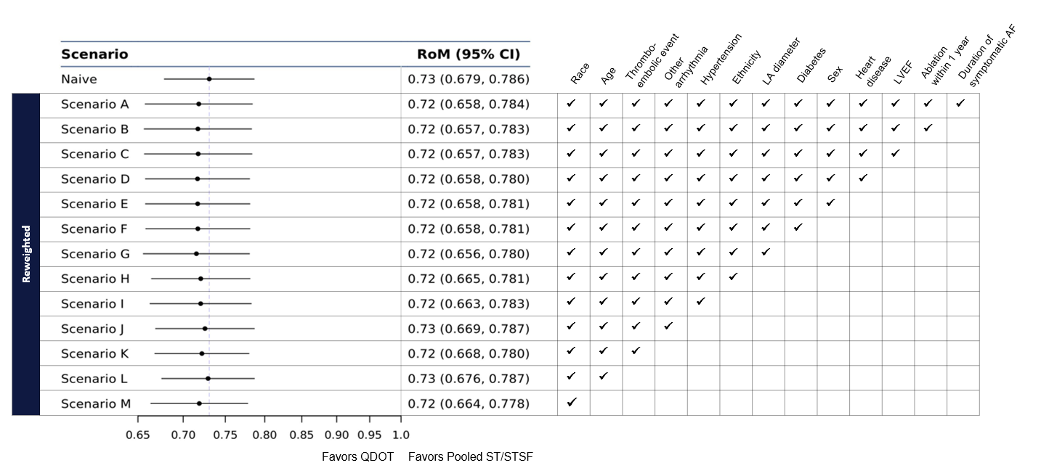
Scenario A adjusts for all available ranked factors; race (non-white), age, thromboembolic event (composite), other arrhythmia (composite), hypertension, ethnicity (Hispanic/Latino), left atria diameter, diabetes, sex (female), heart disease (composite), left ventricular ejection fraction, ablation procedure within 1 year prior to enrollment, and duration of symptomatic AF in months. Subsequent scenarios (B to M) involved dropping factors one at a time in the order of least to most important, as identified during the ranking procedure.
Abbreviations: AF = atrial fibrillation; CI = confidence interval; LA = left atria; LVEF = left ventricle ejection fraction; RoM = ratio of means
Appendix 8: Forest plot of IPTW results for each fluoroscopy time scenario
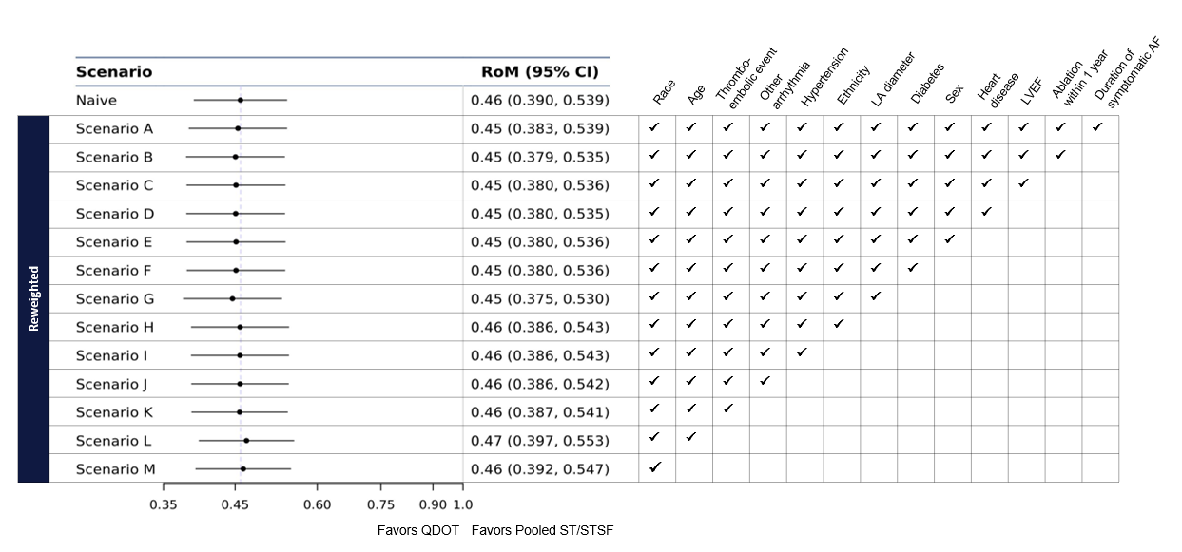
Scenario A adjusts for all available ranked factors; race (non-white), age, thromboembolic event (composite), other arrhythmia (composite), hypertension, ethnicity (Hispanic/Latino), left atria diameter, diabetes, sex (female), heart disease (composite), left ventricular ejection fraction, ablation procedure within 1 year prior to enrollment, and duration of symptomatic AF in months. Subsequent scenarios (B to M) involved dropping factors one at a time in the order of least to most important, as identified during the ranking procedure.
Abbreviations: AF = atrial fibrillation; CI = confidence interval; LA = left atria; LVEF = left ventricle ejection fraction; RoM = ratio of means

Appendix 9: Kaplan-Meier curve of clinical success at 12 months (adjusted for all factors)
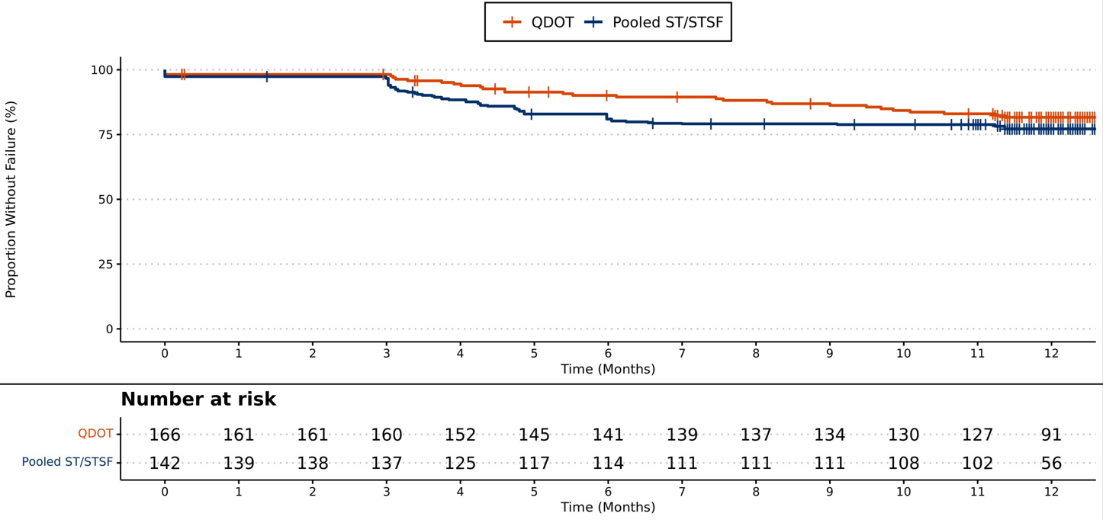

Appendix 10: Forest plot of IPTW results for each clinical success at 12 months scenario
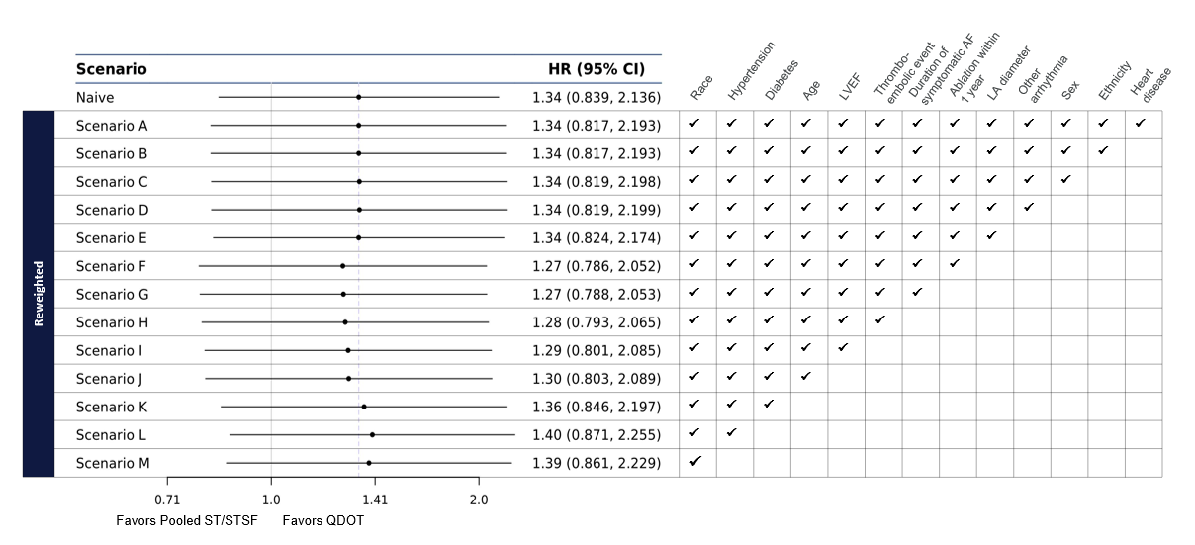
Scenario A adjusts for all available ranked factors; race (non-white), hypertension, diabetes, age, left ventricular ejection fraction, thromboembolic event (composite), duration of symptomatic AF in months, ablation within 1 year from enrollment, left atria diameter, other arrhythmia (composite), sex (female), ethnicity (Hispanic/Latino), and heart disease. Subsequent scenarios (B to M) involved dropping factors one at a time in the order of least to most important, as identified during the ranking procedure.
Abbreviations: AF = atrial fibrillation; CI = confidence interval; HR = hazard ratio; LA = left atria; LVEF = left ventricle ejection fraction

Appendix 11: Forest plot of IPTW results for rhythm monitoring-adjusted recurrence scenario
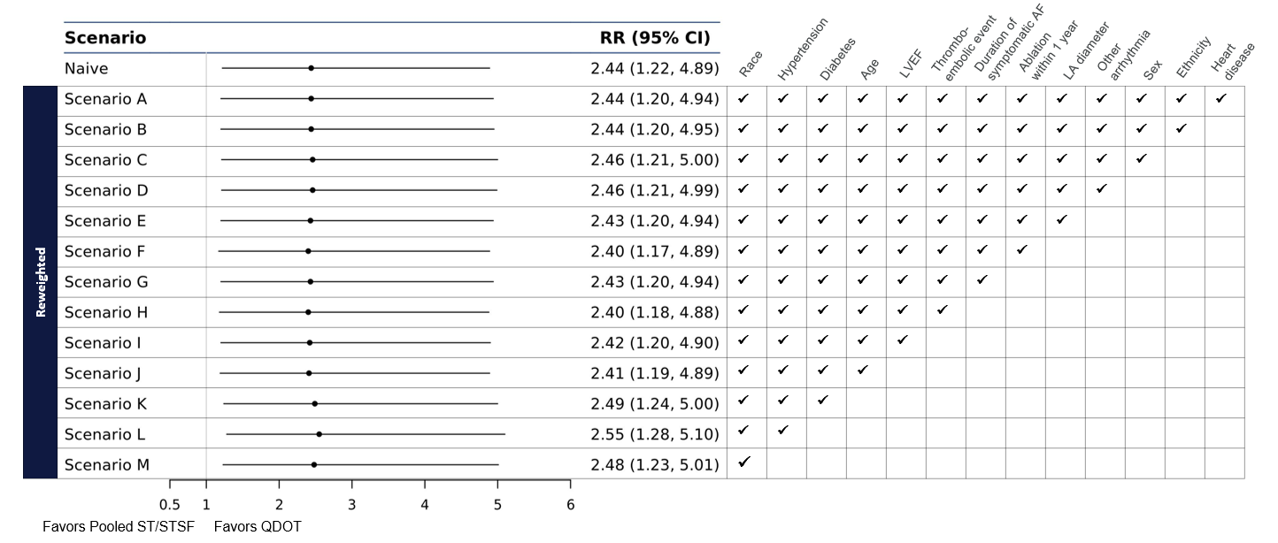
Scenario A adjusts for all available ranked factors; race (non-white), hypertension, diabetes, age, left ventricular ejection fraction, thromboembolic event (composite), duration of symptomatic AF in months, ablation within 1 year from enrollment, left atria diameter, other arrhythmia (composite), sex (female), ethnicity (Hispanic/Latino), and heart disease. Subsequent scenarios (B to M) involved dropping factors one at a time in the order of least to most important, as identified during the ranking procedure.
Abbreviations: AF = atrial fibrillation; CI = confidence interval; LA = left atria; LVEF = left ventricle ejection fraction; RR = rate ratio

